Lifecycle Methods



**Steps:** Writing code for @BeforeAll annotation, @BeforeEach annotation, @AfterAll annotation, and @AfterEach annotation:

Below is a sample program that includes all the annotations mentioned above. These annotations play a very specific role in the test execution order.

* @BeforeAll is used to signal that the annotated method must be executed before all the tests in the current test class.
* @BeforeEach is used to signal that the annotated method must be executed before each @Test method in the current class.
* @AfterAll is used to signal that the annotated method must be executed after all the tests in the current test class.
* @AfterEach is used to signal that the annotated method must be executed after each @Test method in the current class.
* 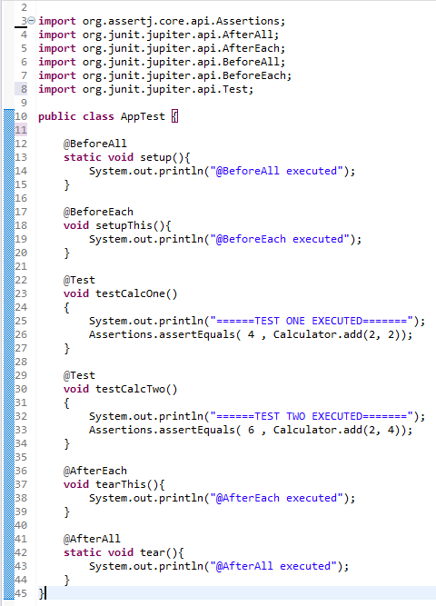

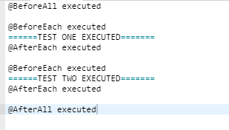

**Steps:** Pushing the code to your GitHub repositories:

Open your command prompt and navigate to the folder where you have created your files:

cd <folder path>

Initialize your repository using the following command:

git init

Add all the files to your git repository using the following command:

git add . 

Commit the changes using the following command:

git commit . -m “Changes have been committed.”

Push the files to the folder you initially created using the following command:

git push -u origin master